**BHARATI VIDYAPEETH UNIVERSITY**

**COLLEGE OF ENGINEERING**

**PUNE**



**CERTIFICATE**

# This is to certify that

# ABHISHEK SINGH RAWAT

**AKASH YADAV**

**DEVESH SINGH MEHRA**

**SAYUJ KOUL**

# has carried out the project on “DETECTING PHISHING WEBSITES USING MACHINE LEARNING” under my guidance in partial fulfillment of the requirement for the diploma in Network Security of Bharati Vidyapeeth (to be Deemed) University, Pune during the academic year 2017-18.

**Miss. Jyoti Singhal Prof. Dr. S. B. Vanjale**  (Project Guide) (Coordinator Network Security)

**Date: 24/03/2018**

**Place: Pune**

**Acknowledgement**

I wish to extend my sincere gratitude to my project guide, **Ms.** **Jyoti Singhal** Lecturer, Department of Network Security, for her valuable guidance and encouragement which has been absolutely helpful in successful completion of this project.

I am indebted to **Prof. S. B. Vanjale**, Professor and Coordinator of Network Security for his valuable support.

I am also grateful to my parents and friends for their timely aid without which I wouldn’t have finished my seminar successfully. I extend my thanks to all my well-wishers and all those who have contributed directly and indirectly for the completion of this work.

And last but not the least; I thank God Almighty for his blessings without which the completion of this seminar would not have been possible.

**CONTENT**

1. Abstract
2. List of Acronyms
3. List of Figures
4. Chapter -1 Introduction

1.1 Problem Definition

* 1. Scope and Objective
  2. Methodology
  3. Literature Survey

1. Chapter -2 Detection Technique

2.1 Introduction

2.2 Phishing websites Detection Technique

2.3 Algorithm

1. Chapter -3 Data Set

3.1 Introduction

3.2 Data Set

* 1. Tools

1. Conclusion
2. Bibliography

**ABSTRACT**

Phishing sites which expects to take the victims confidential data by diverting them to surf a fake website page that resembles a honest to goodness one is another type of criminal acts through the internet and its one of the especially concerns toward numerous areas including e-managing an account and retailing. Phishing site detection is truly an unpredictable and element issue including numerous components and criteria that are not stable. On account of the last and in addition ambiguities in arranging sites because of the intelligent procedures programmers are utilizing, some keen proactive strategies can be helpful and powerful tools can be utilized, for example, fuzzy, neural system and data mining methods can be a successful mechanism in distinguishing phishing sites. We applied Random Forest (RF), one of the different types of machine learning based algorithms used for detection of Phishing websites. Finally we measured and compared the performance of the classifier in terms of accuracy.

**Chapter 1**

**Introduction**

Phishing is a type of extensive fraud that happens when a malicious website act like a real one keeping in mind that the end goal to obtain touchy data, for example, passwords, account points of interest, or MasterCard numbers.

In spite of the fact that there are a few contrary to phishing programming and methods for distinguishing potential phishing endeavours in messages and identifying phishing substance on sites, phishes think of new and half breed strategies to go around the accessible programming and systems.

Phishing is a trickery system that uses a blend of social designing what's more, innovation to assemble delicate and individual data, for example, passwords and charge card subtle elements by taking on the appearance of a dependable individual or business in an electronic correspondence. Phishing makes utilization of spoof messages that are made to look valid and implied to be originating from honest to goodness sources like money related foundations, ecommerce destinations and so forth, to draw clients to visit fake sites through joins gave in the phishing email. The misleading sites are intended to emulate the look of a genuine organization site page.

The employing so as to phishing invader's trap clients diverse social building strategies, for example, debilitating to suspend client accounts on the off chance that they don't finish the account upgrade process, give other data to approve their records or a few different motivations to get the clients to visit their satirize page.

Supervised learning (Classification Technique) accommodates a vastly improved precision while unsupervised learning accommodates a quick and dependable way to deal with infer information from a dataset. That's why we used supervised learning in our work.

* 1. **Problem Definition**

Detection of Malicious URLs websites hosting phishing, spam etc by using Machine Learning.

* 1. **Scope and Objectives**

The system should be useful in many e-commercial websites for maintaining the security and reliability of customers and people online

The system should be useful in preventing online frauds leading to leakage of important and private user data

The scope of using Machine Language over other Traditional Detecting Methods

Objectives:

* Understanding phishing domain (or Fraudulent Domain) characteristics, its distinguishing features from legitimate domains
* Why it is so important to detect this domain and how they can be detected using machine learning and natural language processing techniques
* Reviewing the state-of-the-art machine learning techniques for malicious URL detection in literature
* Understanding the newly emerging concept of Malicious URL Detection as a service and the principles to be used while designing such a system.

To distinguish the phishing websites from the legitimate websites and ensure secure transactions to users

* 1. **Methodology**

There are a lot of algorithms and a wide variety of data types for phishing detection in the academic literature and commercial products. A phishing URL and the corresponding page have several features which can be differentiated from a malicious URL. For example; an attacker can register long and confusing domain to hide the actual domain name (Cyber squatting, Typo squatted)

Features collected from academic studies for the phishing domain detection with machine learning techniques are grouped as given below.

1. URL-Based Features
2. Domain-Based Features
3. Page-Based Features
4. Content-Based Features

Mainly there is use of Natural Language Processing (NLP) and other machine learning techniques. Moreover much use more technical features and process them using machine learning algorithms has been imposed.

* 1. **Literature Survey**

There are number of users who purchase products online and make payment through various websites. The Anti-Phishing Working Group (APWG) has published the “[Global Phishing Survey 2H2014](http://apwg.org/download/document/245/APWG_Global_Phishing_Report_2H_2014.pdf)“, a report that comes with some interesting numbers on phishing activities. The Global Phishing Survey 2H2014 report states that in the second half of 2014 the domain names used for [phishing](http://securityaffairs.co/wordpress/33658/cyber-crime/attackers-use-phishing-kits-campaigns.html) broke a record, at least 123,972 unique attacks were observed all over the world, reaching the amazing figure of 95.321 unique domain names.(‘ Global Phishing Survey: Trends and Domain Name Use in 2H2014’)

Many users unwittingly click phishing domains every day and every hour. The attackers are targeting both the users and the companies. According to the 3rd Microsoft Computing Safer Index Report, released in February 2014, the annual worldwide impact of phishing could be very high as $5 billion.[“<https://www.normshield.com/phishing-domain-detection-with-machine-learning/>”]

“Of the 95,321 phishing domains, we identified 27,253 domain names that we believe were registered maliciously, by phishers,”.”This is an all-time high, and much higher than the 22,629 we identified in 1H2014. Most of these registrations were made by Chinese phishers. The other 68,303 domains were almost all hacked or compromised on vulnerable Web hosting.”[ ‘ Global Phishing Survey: Trends and Domain Name Use in 2H2014’]

Below the key findings of the Global Phishing Survey 2H2014 report:

* *We identified 27,253 domain names that we believe were registered maliciously, by phishers. This is an all-time high, and much higher than the 22,629 we identified in 1H2014. Most of these registrations were made by Chinese phishers. The other 68,303 domains were almost all hacked or compromised on the vulnerable Web hosting.*
* *Seventy-five percent of the malicious domain registrations were in just five TLDs: .COM, .TK, .PW, .CF, and* .*NET.*
* *In addition, 3,582 attacks were detected on 3,095 unique IP addresses, rather than on domain names. (For example: http://77.101.56.126/FB/) We did not observe phish of any kind on IPv6 addresses.*
* *We counted 569 targeted institutions. This is down significantly from the all-time high of 756 we observed in 1H2014*
* *The average uptime in 2H2014 was 29 hours and 51 minutes. The median uptime in 2H2014 increased to 10 hours 6 minutes, meaning that half of all phishing attacks stay active for slightly more than 10 hours.*
* *Phishing occurred in 272 top-level domains (TLDs). Fifty-six of them were new top-level domains.*
* *Only 1.9 percent of all domain names that were used for phishing contained a brand name or variation thereof. (See “Compromised Domains vs. Malicious Registrations”[* ‘ Global Phishing Survey: Trends and Domain Name Use in 2H2014’*]*

To give you an idea of the record numbers in the second half of 2014, the Global Phishing Survey 2H2014 includes a table comparing malicious activities over the years:

[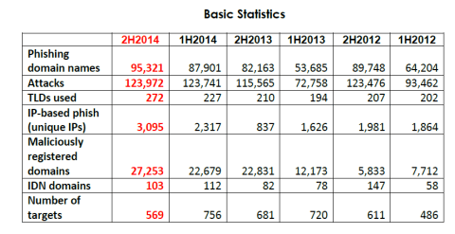](https://i1.wp.com/securityaffairs.co/wordpress/wp-content/uploads/2015/06/APWG-phishing-activities.png)

*“Phishers continued to attack Apple, PayPal, and Taobao.com heavily. Each of these three e-commerce giants suffered over 20,000 phishing attacks against their respective services and brands. Together, these top three were the targets of nearly 54 percent of the world’s phishing attacks. The next seven brands were targeted for a combined 23 percent of all phishing attacks — meaning the top 10 targets accounted for over* three quarters *of all phishing attacks observed worldwide. The number of times that the targets were attacked follows a long tail. Half of the targets were attacked four or fewer times during the six-month period (up from three times in 1H2014). One hundred and fifty-eight targets were attacked only once each in the period.”[* ‘ Global Phishing Survey: Trends and Domain Name Use in 2H2014’*]*

Other interesting trends highlighted in the Global Phishing Survey 2H2014 report are:

* *New companies are constantly being targeted by phishers. Some phishers are attacking targets where consumers may least expect it.*
* *The ten companies that are targeted most often by phishers are attacked constantly, sometimes more than 1,000 times per month. Together the top ten targets suffered more than three-quarters of all the phishing attacks observed worldwide.*
* *The number of domain names used for phishing reached an all-time high.*
* *Phishing in the new top-level domains started slowly. We expect to see phishing levels in them rise as time goes on.*
* *Chinese phishers were responsible for 85% of the domain names that were registered for phishing. These phishers started using .CN domains more frequently.*
* *Phishing attacks were not mitigated as quickly. The median uptime of phishing attacks increased to 10 hours 6 minutes — up from 8 hours and 42 minutes in 1H2014. This means that phishing attacks were not being shut down as efficiently in the critical first hours, when most victims fall prey.*
* *If attacks are divided by Industry, we can clearly see that the* makers *involving money are the ones more targeted like it can be seen the in the next chart:*

[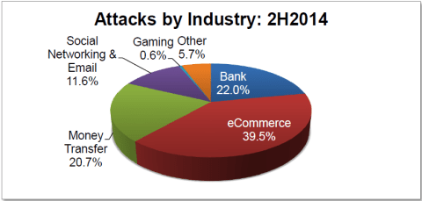](https://i2.wp.com/securityaffairs.co/wordpress/wp-content/uploads/2015/06/APWG-attacks-by-Industry.png)

*That proves that “These show criminals seeking the credentials of consumers in places where consumers may least expect it. Phishers target wide-ranging targets for several reasons. One is to perform credit card theft, and hitting new targets may lull consumers into a false sense of security. The phishers can also monetize stolen data through reshipping fraud, a tactic that remains popular. Phishers also steal usernames and passwords from one site in order to try those credential on other sites. Many consumers re-use usernames and passwords, and this poor habit can be costly. If a site is getting phished for the first time, it may have been targeted by a more sophisticated phisher, who had the skill to design a new phishing template.”[* ‘ Global Phishing Survey: Trends and Domain Name Use in 2H2014’*]*

* 1. **Motivation**

Malicious URL, a.k.a. malicious website, is a common and serious threat to cyber security. Malicious URLs host unsolicited content (spam, phishing, drive-by exploits, etc.) and lure unsuspecting users to become victims of scams (monetary loss, theft of private information, and malware installation), and cause losses of billions of dollars every year. It is imperative to detect and act on such threats in a timely manner. Traditionally, this detection is done mostly through the usage of blacklists.

However, blacklists cannot be exhaustive, and lack the ability to detect newly generated malicious URLs. To improve the generality of malicious URL detectors, machine learning techniques have been explored with increasing attention in recent years. The project aims to provide a comprehensive survey and a structural understanding of Malicious URL Detection techniques using

machine learning. We present the formal formulation of Malicious URL Detection as a machine learning task and categorize and review the contributions of literature studies that addresses different dimensions of this problem (feature representation, algorithm design, etc.).

**Chapter 2**

**Detection Technique**

**2.1 Introduction**

Detection of phishing websites has received a lot of attention recently due to their impact on users’ security. Therefore, many techniques have been developed to detect phishing websites varying from communication-oriented techniques, such as authentication protocols, blacklisting, and white-listing, to content-based filtering techniques. The blacklisting and white-listing techniques have not proven though to be sufficiently efficient when used in different domains, and thus they are not commonly used. Meanwhile, the content-based phishing filters have been widely used and have proven to be of high efficiency. In light of this, researches have focused on content-based mechanism and on developing machine learning and data mining techniques based on the header and body of emails.

**2.2 Phishing websites Detection Technique**

**2.3 Algorithm**

**Chapter 3**

**Data Set**

**3.1 Introduction**

**3.2 Data Set**

One of the challenges faced by our research was the unavailability of reliable training datasets. In fact, this challenge faces any researcher in the field. However, although plenty of articles about predicting phishing websites using data mining techniques have been disseminated these days, no reliable training dataset has been published publically, maybe because there is no agreement in literature on the definitive features that characterize phishing websites, hence it is difficult to shape a dataset that covers all possible features.

In this article, we shed light on the important features that have proved to be sound and effective in predicting phishing websites. In addition, we proposed some new features, experimentally assign new rules to some well-known features and update some other features.

### Address Bar based Features

#### Using the IP Address

If an IP address is used as an alternative of the domain name in the URL, such as “<http://125.98.3.123/fake.html>”, users can be sure that someone is trying to steal their personal information. Sometimes, the IP address is even transformed into hexadecimal code as shown in the following link “<http://0x58.0xCC.0xCA.0x62/2/paypal.ca/index.html>”.

*Rule*:IF

#### Long URL to Hide the Suspicious Part

Phishers can use long URL to hide the doubtful part in the address bar. For example:

<http://federmacedoadv.com.br/3f/aze/ab51e2e319e51502f416dbe46b773a5e/?cmd=_home&amp;dispatch=11004d58f5b74f8dc1e7c2e8dd4105e811004d58f5b74f8dc1e7c2e8dd4105e8>@phishing.website.html

To ensure accuracy of our study, we calculated the length of URLs in the dataset and produced an average URL length. The results showed that if the length of the URL is greater than or equal 54 characters then the URL classified as phishing. By reviewing our dataset we were able to find 1220 URLs lengths equals to 54 or more which constitute 48.8% of the total dataset size.

*Rule: IF*

We have been able to update this feature rule by using a method based on frequency and thus improving upon its accuracy.

#### Using URL Shortening Services “TinyURL”

URL shortening is a method on the “World Wide Web” in which a URL may be made considerably smaller in length and still lead to the required webpage. This is accomplished by means of an “HTTP Redirect” on a domain name that is short, which links to the webpage that has a long URL. For example, the URL “http://portal.hud.ac.uk/” can be shortened to “bit.ly/19DXSk4”.

*Rule*:IF

#### URL’s having “@” Symbol

Using “@” symbol in the URL leads the browser to ignore everything preceding the “@” symbol and the real address often follows the “@” symbol.

Rule: IF

#### Redirecting using “//”

The existence of “//” within the URL path means that the user will be redirected to another website. An example of such URL’s is: “http://www.legitimate.com//http://www.phishing.com”. We examin the location where the “//” appears. We find that if the URL starts with “HTTP”, that means the “//” should appear in the sixth position. However, if the URL employs “HTTPS” then the “//” should appear in seventh position.

Rule: IF

#### Adding Prefix or Suffix Separated by (-) to the Domain

The dash symbol is rarely used in legitimate URLs. Phishers tend to add prefixes or suffixes separated by (-) to the domain name so that users feel that they are dealing with a legitimate webpage. For example http://www.Confirme-paypal.com/.

Rule:IF

#### Sub Domain and Multi Sub Domains

Let us assume we have the following link: http://www.hud.ac.uk/students/. A domain name might include the country-code top-level domains (ccTLD), which in our example is “uk”. The “ac” part is shorthand for “academic”, the combined “ac.uk” is called a second-level domain (SLD) and “hud” is the actual name of the domain. To produce a rule for extracting this feature, we firstly have to omit the (www.) from the URL which is in fact a sub domain in itself. Then, we have to remove the (ccTLD) if it exists. Finally, we count the remaining dots. If the number of dots is greater than one, then the URL is classified as “Suspicious” since it has one sub domain. However, if the dots are greater than two, it is classified as “Phishing” since it will have multiple sub domains. Otherwise, if the URL has no sub domains, we will assign “Legitimate” to the feature.

Rule:IF

#### HTTPS (Hyper Text Transfer Protocol with Secure Sockets Layer)

The existence of HTTPS is very important in giving the impression of website legitimacy, but this is clearly not enough. The authors in (Mohammad, Thabtah and McCluskey 2012)(Mohammad, Thabtah and McCluskey 2013) suggest checking the certificate assigned with HTTPS including the extent of the trust certificate issuer, and the certificate age. Certificate Authorities that are consistently listed among the top trustworthy names include: “GeoTrust, [GoDaddy](http://www.godaddy.com/gdshop/ssl/ssl.asp?isc=BESTSSL1), Network Solutions, Thawte, Comodo, Doster and VeriSign”. Furthermore, by testing out our datasets, we find that the minimum age of a reputable certificate is two years.

Rule:IF

#### Domain Registration Length

Based on the fact that a phishing website lives for a short period of time, we believe that trustworthy domains are regularly paid for several years in advance. In our dataset, we find that the longest fraudulent domains have been used for one year only.

Rule:IF

#### Favicon

A favicon is a graphic image (icon) associated with a specific webpage. Many existing user agents such as graphical browsers and newsreaders show favicon as a visual reminder of the website identity in the address bar. If the favicon is loaded from a domain other than that shown in the address bar, then the webpage is likely to be considered a Phishing attempt.

Rule:IF

#### Using Non-Standard Port

This feature is useful in validating if a particular service (e.g. HTTP) is up or down on a specific server. In the aim of controlling intrusions, it is much better to merely open ports that you need. Several firewalls, Proxy and Network Address Translation (NAT) servers will, by default, block all or most of the ports and only open the ones selected. If all ports are open, phishers can run almost any service they want and as a result, user information is threatened. The most important ports and their preferred status are shown in Table 2.

Rule:IF

Table Common ports to be checked

|  |  |  |  |
| --- | --- | --- | --- |
| PORT | Service | Meaning | Preferred Status |
| 21 | FTP | Transfer files from one host to another | Close |
| 22 | SSH | Secure File Transfer Protocol | Close |
| 23 | Telnet | provide a bidirectional interactive text-oriented communication | Close |
| 80 | HTTP | Hyper test transfer protocol | Open |
| 443 | HTTPS | Hypertext transfer protocol secured | Open |
| 445 | SMB | Providing shared access to files, printers, serial ports | Close |
| 1433 | MSSQL | Store and retrieve data as requested by other software applications | Close |
| 1521 | ORACLE | Access oracle database from web. | Close |
| 3306 | MySQL | Access MySQL database from web. | Close |
| 3389 | Remote Desktop | allow remote access and remote collaboration | Close |

#### The Existence of “HTTPS” Token in the Domain Part of the URL

The phishers may add the “HTTPS” token to the domain part of a URL in order to trick users. For example,  
http://https-www-paypal-it-webapps-mpp-home.soft-hair.com/.

Rule:IF

### Abnormal Based Features

#### Request URL

Request URL examines whether the external objects contained within a webpage such as images, videos and sounds are loaded from another domain. In legitimate webpages, the webpage address and most of objects embedded within the webpage are sharing the same domain.

Rule:IF

#### URL of Anchor

An anchor is an element defined by the <a> tag. This feature is treated exactly as “Request URL”. However, for this feature we examine:

1. If the <a> tags and the website have different domain names. This is similar to request URL feature.
2. If the anchor does not link to any webpage, e.g.:
3. <a href=“#”>
4. <a href=“#content”>
5. <a href=“#skip”>
6. <a href=“JavaScript ::void(0)”>

*Rule*: IF

#### Links in <Meta>, <Script> and <Link> tags

Given that our investigation covers all angles likely to be used in the webpage source code, we find that it is common for legitimate websites to use <Meta> tags to offer metadata about the HTML document; <Script> tags to create a client side script; and <Link> tags to retrieve other web resources. It is expected that these tags are linked to the same domain of the webpage.

Rule: IF

#### Server Form Handler (SFH)

SFHs that contain an empty string or “about:blank” are considered doubtful because an action should be taken upon the submitted information. In addition, if the domain name in SFHs is different from the domain name of the webpage, this reveals that the webpage is suspicious because the submitted information is rarely handled by external domains.

Rule:IF

#### Submitting Information to Email

Web form allows a user to submit his personal information that is directed to a server for processing. A phisher might redirect the user’s information to his personal email. To that end, a server-side script language might be used such as “mail()” function in PHP. One more client-side function that might be used for this purpose is the “mailto:” function.

Rule:IF

#### Abnormal URL

This feature can be extracted from WHOIS database. For a legitimate website, identity is typically part of its URL.

Rule: IF

### HTML and JavaScript based Features

#### Website Forwarding

The fine line that distinguishes phishing websites from legitimate ones is how many times a website has been redirected. In our dataset, we find that legitimate websites have been redirected one time max. On the other hand, phishing websites containing this feature have been redirected at least 4 times.

Rule:IF

#### Status Bar Customization

Phishers may use JavaScript to show a fake URL in the status bar to users. To extract this feature, we must dig-out the webpage source code, particularly the “onMouseOver” event, and check if it makes any changes on the status bar.

Rule:IF

#### Disabling Right Click

Phishers use JavaScript to disable the right-click function, so that users cannot view and save the webpage source code. This feature is treated exactly as “Using onMouseOver to hide the Link”. Nonetheless, for this feature, we will search for event “event.button==2” in the webpage source code and check if the right click is disabled.

Rule:IF

#### Using Pop-up Window

It is unusual to find a legitimate website asking users to submit their personal information through a pop-up window. On the other hand, this feature has been used in some legitimate websites and its main goal is to warn users about fraudulent activities or broadcast a welcome announcement, though no personal information was asked to be filled in through these pop-up windows.

Rule: IF

#### IFrame Redirection

IFrame is an HTML tag used to display an additional webpage into one that is currently shown. Phishers can make use of the “iframe” tag and make it invisible i.e. without frame borders. In this regard, phishers make use of the “frameBorder” attribute which causes the browser to render a visual delineation.

Rule: IF

### Domain based Features

#### Age of Domain

This feature can be extracted from WHOIS database (Whois 2005). Most phishing websites live for a short period of time. By reviewing our dataset, we find that the minimum age of the legitimate domain is 6 months.

Rule: IF

#### DNS Record

For phishing websites, either the claimed identity is not recognized by the WHOIS database (Whois 2005) or no records founded for the hostname (Pan and Ding 2006). If the DNS record is empty or not found then the website is classified as “Phishing”, otherwise it is classified as “Legitimate”.

Rule:IF

#### Website Traffic

This feature measures the popularity of the website by determining the number of visitors and the number of pages they visit. However, since phishing websites live for a short period of time, they may not be recognized by the Alexa database (Alexa the Web Information Company., 1996). By reviewing our dataset, we find that in worst scenarios, legitimate websites ranked among the top 100,000. Furthermore, if the domain has no traffic or is not recognized by the Alexa database, it is classified as “Phishing”. Otherwise, it is classified as “Suspicious”.

Rule:IF

#### PageRank

PageRank is a value ranging from “0” to “1”. PageRank aims to measure how important a webpage is on the Internet. The greater the PageRank value the more important the webpage. In our datasets, we find that about 95% of phishing webpages have no PageRank. Moreover, we find that the remaining 5% of phishing webpages may reach a PageRank value up to “0.2”.

Rule:IF

#### Google Index

This feature examines whether a website is in Google’s index or not. When a site is indexed by Google, it is displayed on search results (Webmaster resources, 2014). Usually, phishing webpages are merely accessible for a short period and as a result, many phishing webpages may not be found on the Google index.

Rule:IF

#### Number of Links Pointing to Page

The number of links pointing to the webpage indicates its legitimacy level, even if some links are of the same domain (Dean, 2014). In our datasets and due to its short life span, we find that 98% of phishing dataset items have no links pointing to them. On the other hand, legitimate websites have at least 2 external links pointing to them.

Rule: IF

#### Statistical-Reports Based Feature

Several parties such as PhishTank (PhishTank Stats, 2010-2012), and StopBadware (StopBadware, 2010-2012) formulate numerous statistical reports on phishing websites at every given period of time; some are monthly and others are quarterly. In our research, we used 2 forms of the top ten statistics from PhishTank: “Top 10 Domains” and “Top 10 IPs” according to statistical-reports published in the last three years, starting in January2010 to November 2012. Whereas for “StopBadware”, we used “Top 50” IP addresses.

Rule: IF

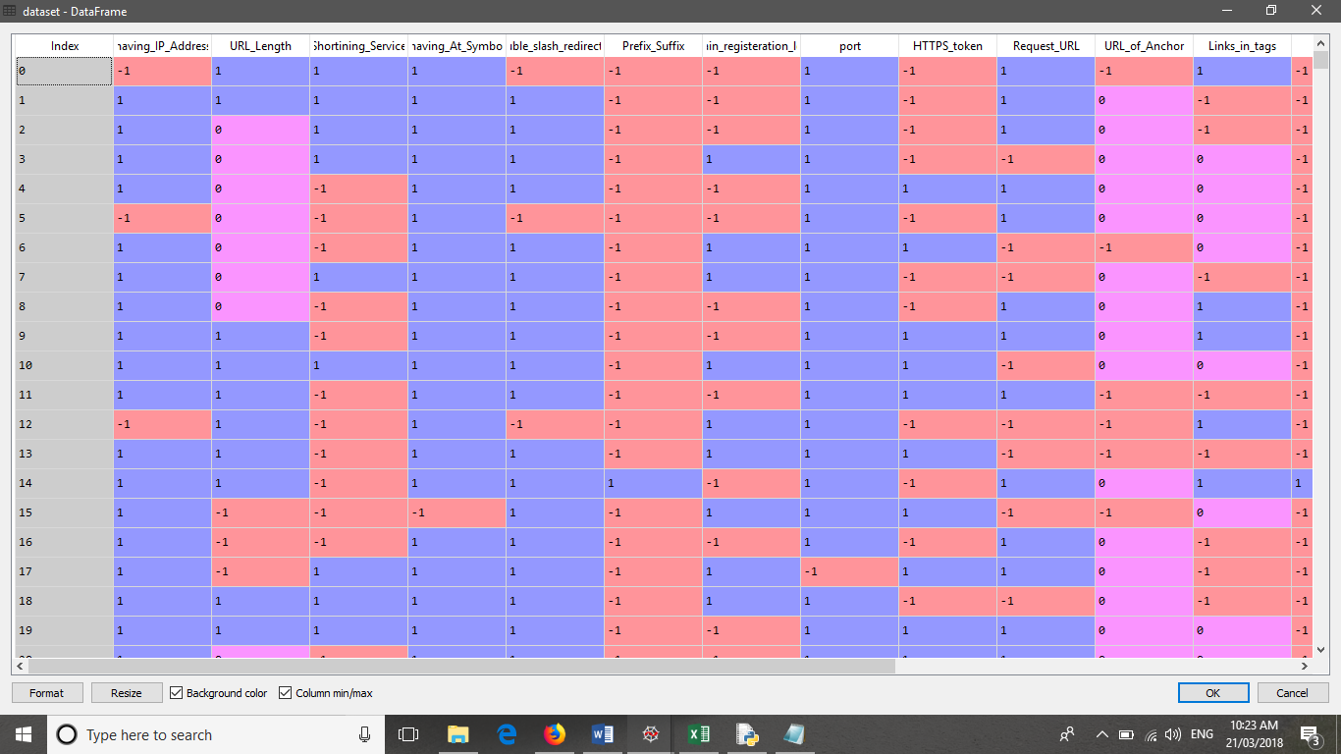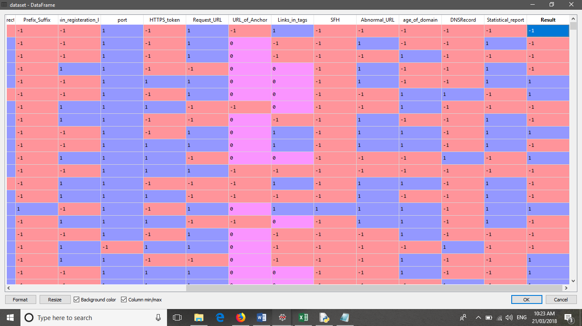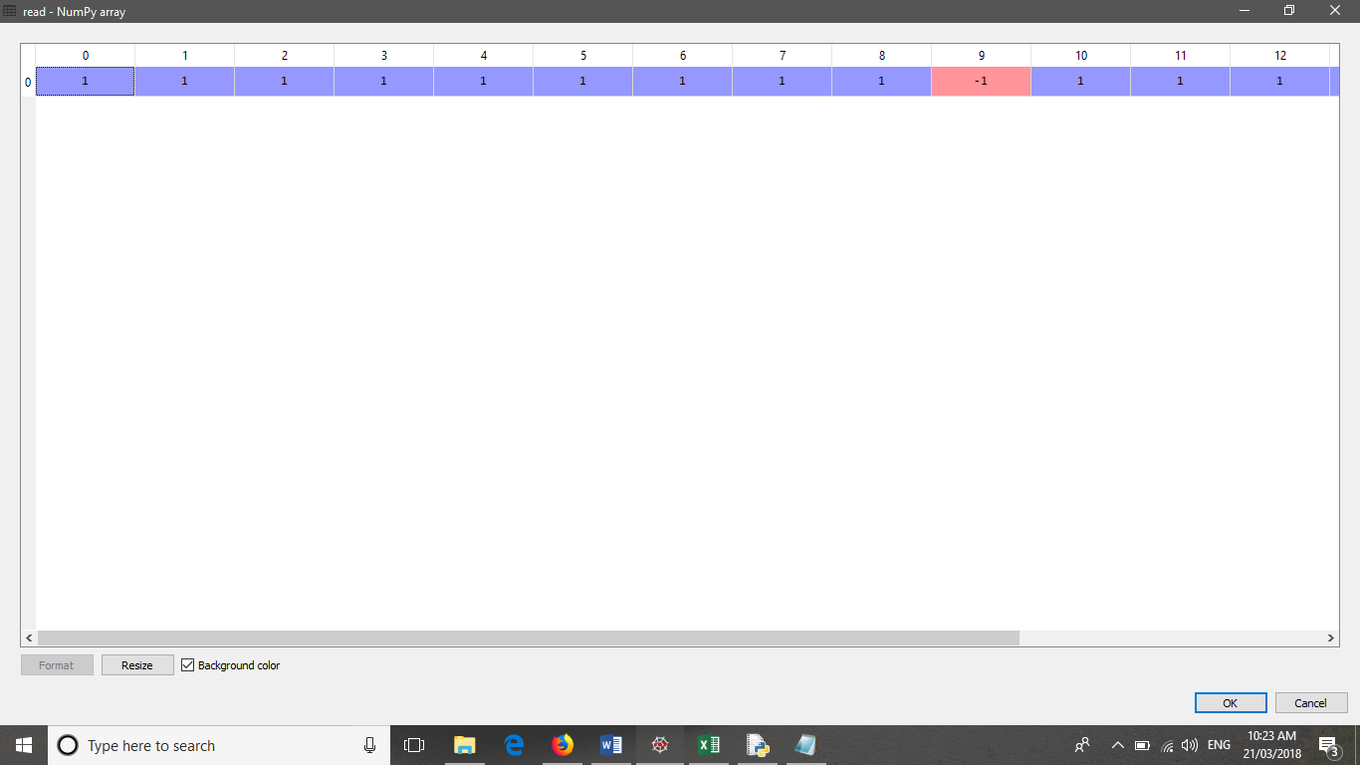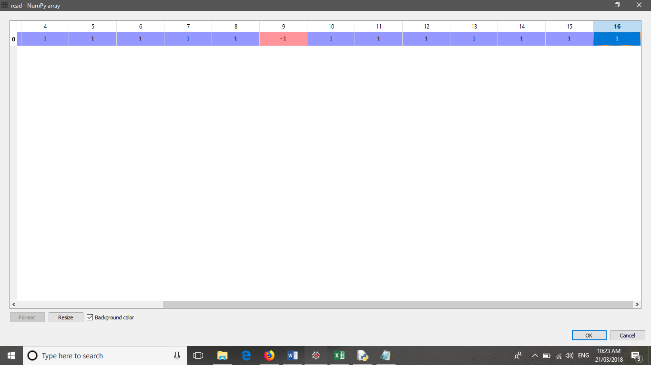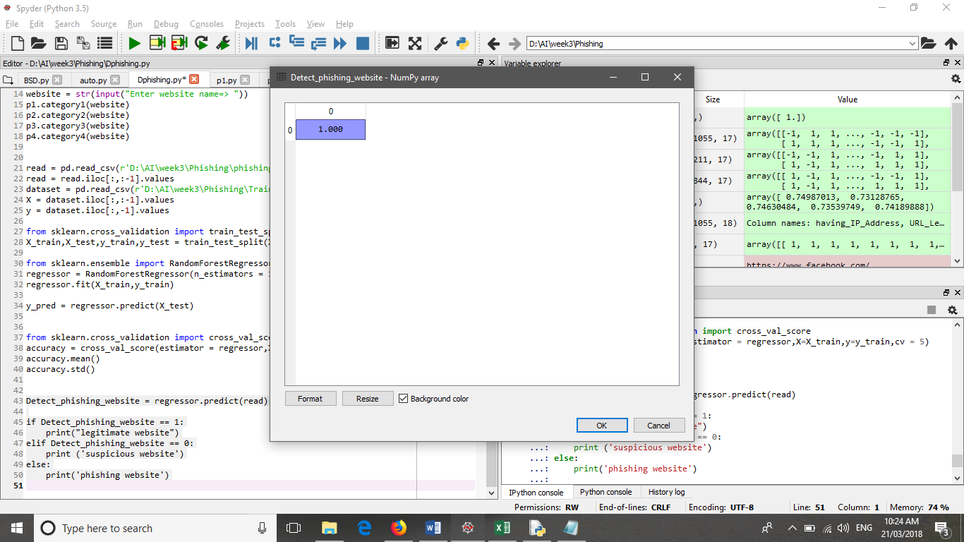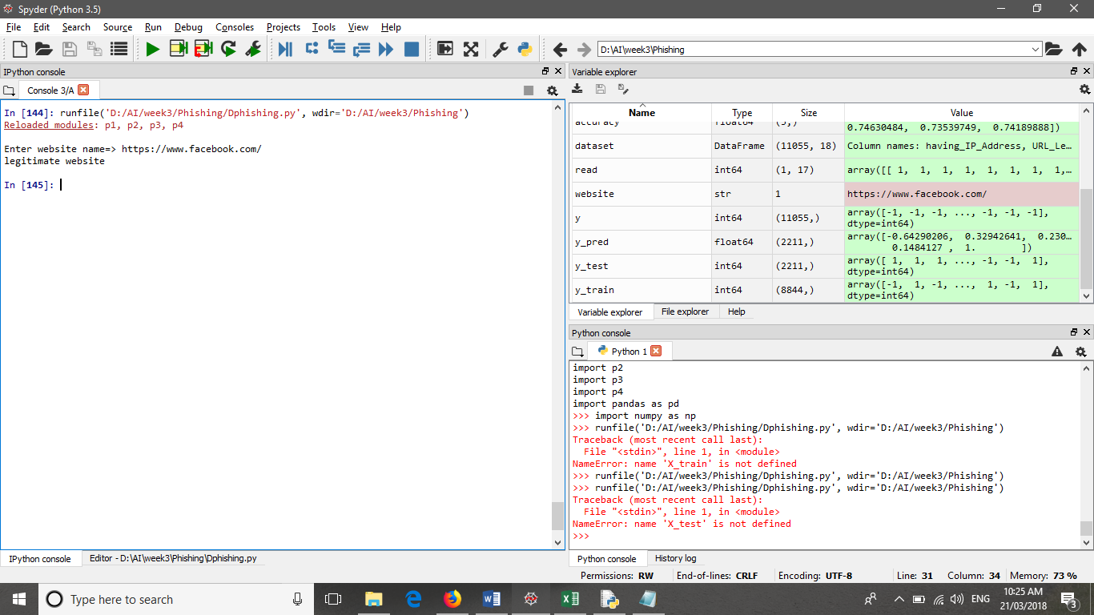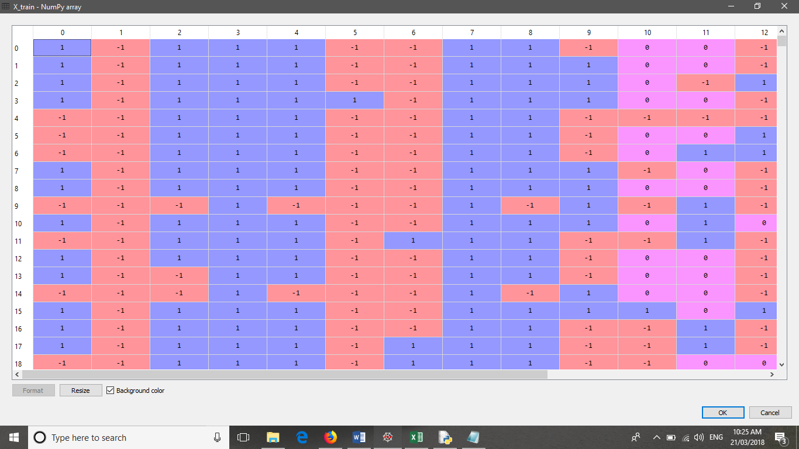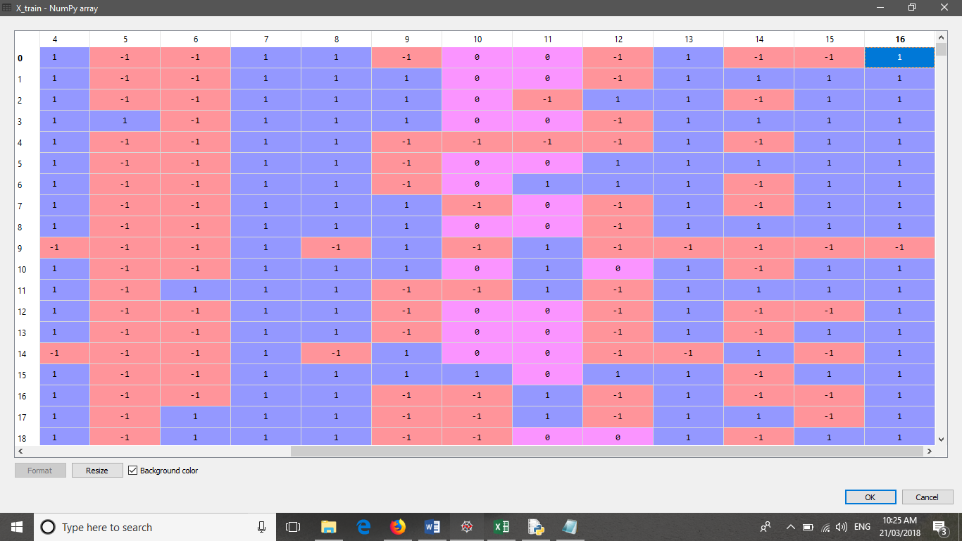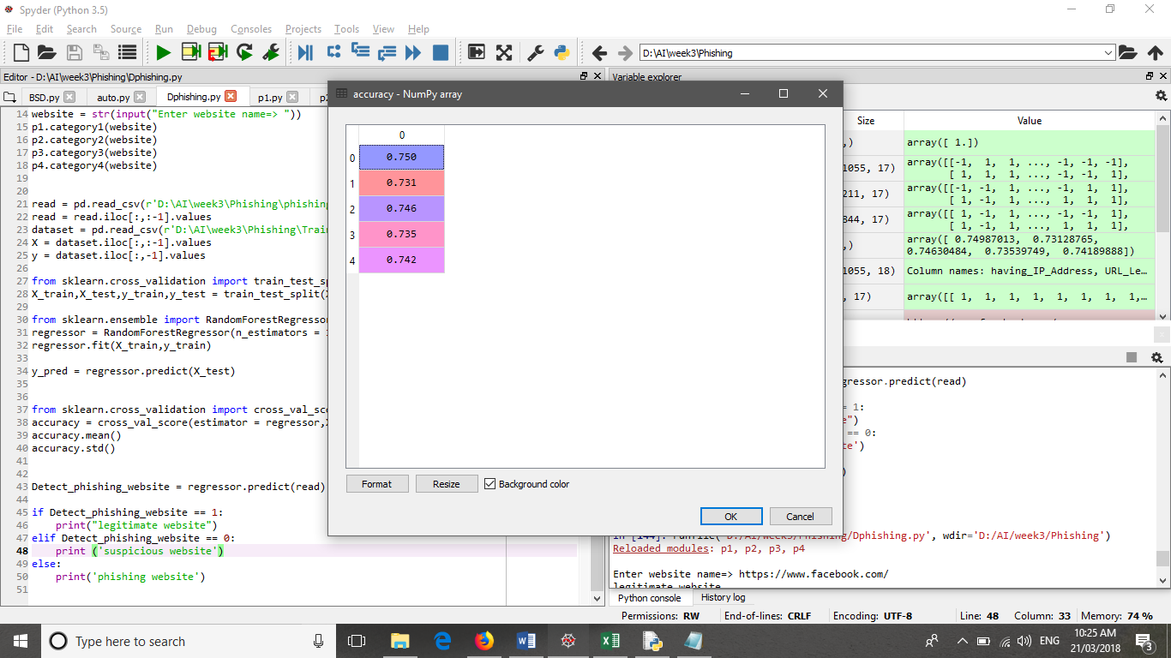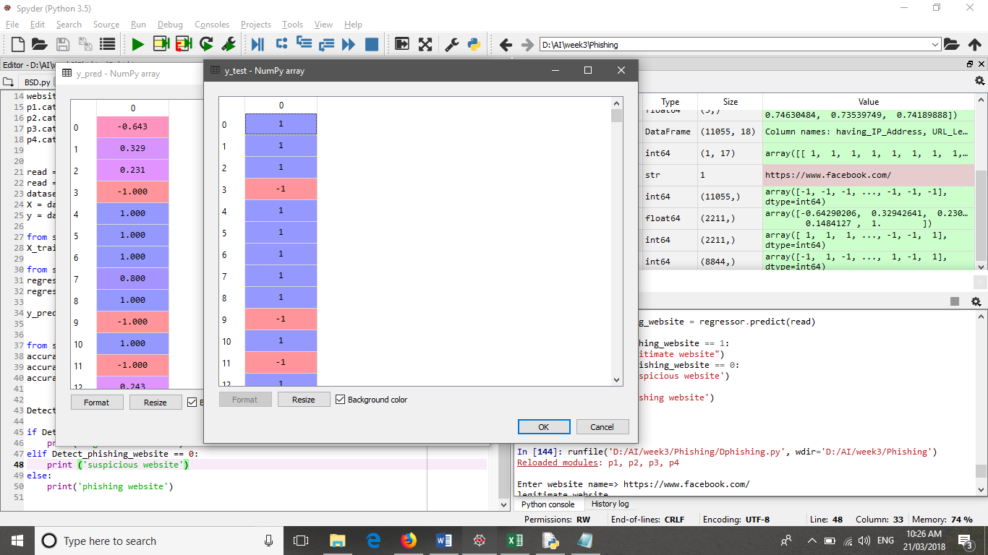

**3.3 Tools**

**Conclusions**

Phishing is a cyber crime procedure utilizing both social building and specialized deception to take individual sensitive data. Besides, Phishing is considered as another extensive type of fraud. Experimentations against recent dependable phishing data sets utilizing different classification algorithm have been performed which received different learning methods. The base of the experiments is accuracy measure.

The aim of this research work is to predict whether a given URL is phishing website or not. It turns out in the given experiment that Random forest based classifiers are the best classifier with great classification accuracy of 75.47% for the given dataset of phishing site. As a future work we might use this model to other Phishing dataset with larger size then now and then testing the performance of those classification algorithm’s in terms of classification accuracy.